**Workbook**

**Web Engineering**

**(SE – 206)**



# Name: Kabeer Ahmed

**Roll No:**   **SE-028**

**Batch:**   **2019**

# Year: Second Year

# Department: Software Engineering

Prepared by

Mrs. Nazish Irfan

I.T Manager,

# Department of Software Engineering

Approved by

Chairman Department of Software Engineering

Table of Contents

|  |  |  |  |
| --- | --- | --- | --- |
| **S. No** | **Object** | **Page No** | **Signatures** |
| 1. | Introduction to HTML. |  |  |
| 2. | Exploring Basic HTML Elements. |  |  |
| 3. | Introduction to HTML5. |  |  |
| 4. | Exploring HTML5 Elements. |  |  |
| 5. | Introduction to Cascading Style Sheets. |  |  |
| 6. | Introduction to JavaScript. |  |  |
| 7. | Introduction to ASP.NET. |  |  |
| 8. | Exploring some controls and the concept of field validation in ASP.NET. |  |  |
| 11. | Introduction to PHP |  |  |
| 12. | PHP Variables, Control Structures and Loops |  |  |
| 13. | MySQL and PHP |  |  |
| 14. | Select, Insert, Update and Delete in PHP/MYSQL |  |  |

# LAB # 1

1. **Which of the following is a properly formed HTML document?**

C. <html>

<head> <title> my document </title> </head>

<body> this is my web page</body>

</html>

1. **What are the advantages and disadvantages of HTML?**

**Advantages:**

* HTML is the basic language to learn for web technologies. It is Very useful for beginners in web designing field.
* Easy to learn and use.
* Easy to code and widely used language. Simple to edit only requires a text editor.
* We can integrate many languages with HTML. Some of them are PHP, java scripts like node Js and many more.2. Every browser supports HTML language.
* Even for learning JavaScript, like for integrating JavaScript into html, we need to know some basics of html. So learning HTML is the basic thing to do, if we want to learn web technologies.
* HTML also allows the use of templates, which makes designing a webpage easy.
* It is by default in every windows so you don't need to purchase extra software. • Very similar to XML syntax, which is increasingly used for data storage
* It is also fast to download (text is highly compressible).
* It is supported by most browsers across most if not all platforms

**Disadvantages:**

* It can create only static and plain pages so if we need dynamic pages then [**HTML**](http://learnwebdevelopment.info/html/)[i](http://learnwebdevelopment.info/html/)s not useful.
* Need to write lot of code for making simple webpage.
* Security features are not good in HTML.
* If we need to write long code for making a webpage then it produces some complexity.
* Errors can be costly.
* Isn't rendered correctly in all browsers
* Isn't really as flexible as other standards or technologies
* It is not centralized (all pages must be edited individually).
* Very limited styling capabilities (we're not talking CSS here!)
* It is essentially massively outdated (XHTML and xml suite of standards).
* Structuring of HTML documents is hard to grasp
* It is static needs to be manually updated or needs some scripting support to change it in some way.

# LAB # 2

1. **Write the HTML tags for :** 
   1. **A paragraph that is a description of a book, include the title of the book as well as its author. Names and titles should be underlined, italicized and bolded.**

**Code:**

<p><strong><em><u>***New Thinking***</u></em></strong> is About Science and Technology What can history's greatest breakthroughs in science and technology teach us about the future? written by <strong><em><u>***Dagogo Altraide***</u></em></strong>.</p>

**Output:**



* 1. **Print two lists with any information you want. One list should be an ordered list and the other should be unordered list.**

**Code:**

<ol>Ordered List

<li>Login</li><li>Sign Up</li><li>Checkout</li><li>Contact</li> </ol>

<ul>Unordered List

<li>Login</li><li>Sign Up</li><li>Checkout</li><li>Contact</li> </ul>

**Output:**

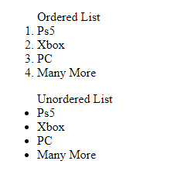

* 1. **Create a page with a link at the top of it when clicked will jump all the way to the bottom of the page and at the bottom of the page there should be a link to jump back to the top of the page.**

**Code:**

<h1 id="top">Top</h1>

<a href="#bottom">Go to Bottom</a>

………….

<h1 id="bottom">Bottom</h1>

<a href="#top">Go To Top</a>

* 1. **Create some links to various search engines.**

**Code:**

<a href ="https://www.google.com">Google</a><br>

<a href ="https://www.facebook.com">Facebook</a><br>

<a href="https://www.wikipedia.org">Wikipedia</a><br>

**Output:**

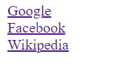

* 1. **Display an image that when clicked will link to a search engine of your choice and the page should open in a new window.**

Code:

<h1>Image As a Hyperlink</h1> <a href="https://www.google.com" target="_blank">

<img src="https://wallpapercave.com/wp/wp2928790.jpg" alt="Image" width="400px" height="400px"></a>

**Output:**



1. **Design a form to take input from the user to generate his / her CV.** Ans:

Code:

<form class="cv">

<h1>CV</h1>

<label>Full Name: <input type="text" name="name" id="name" required ></label><br>

<label>Contact: <input type="text" name="contact" id="contact" required></label><br>

<textarea name="edu" rows="8" cols="80" id="edu" required>Education:</textarea><br>

<textarea name="addr" id="addr" rows="4" cols="40" required>Address:</textarea><br>

<label>Critical Thinking <input type="checkbox" name="skills" id="skills"></label>

<label>Teamwork <input type="checkbox" name="skills" id="skills" ></label>

<label>Leadership <input type="checkbox" name="skills" id="skills" ></label>

<label>Motivational <input type="checkbox" name="skills" id="skills" ></label>

<label>Flxible<input type="checkbox" name="skills" id="skills" ></label><br>

<label for="work">Work Experience</label>

<select class="work" >

<option>1</option><option>2</option><option>5</option><option>Or More</option>

</select><br>

<textarea name="work" id="work" rows="8" cols="80">Place And Year:</textarea><br>

<h4>Professional Skills:</h4>

<label>Soft Developer <input type="radio" name="prof" id="prof"></label>

<label>Graphic Designer<input type="radio" name="prof" id="prof"></label>

<label>Web Developer <input type="radio" name="prof" id="prof"></label>

<label>Data Scientist<input type="radio" name="prof" id="prof"></label>

</form>

**Output:**

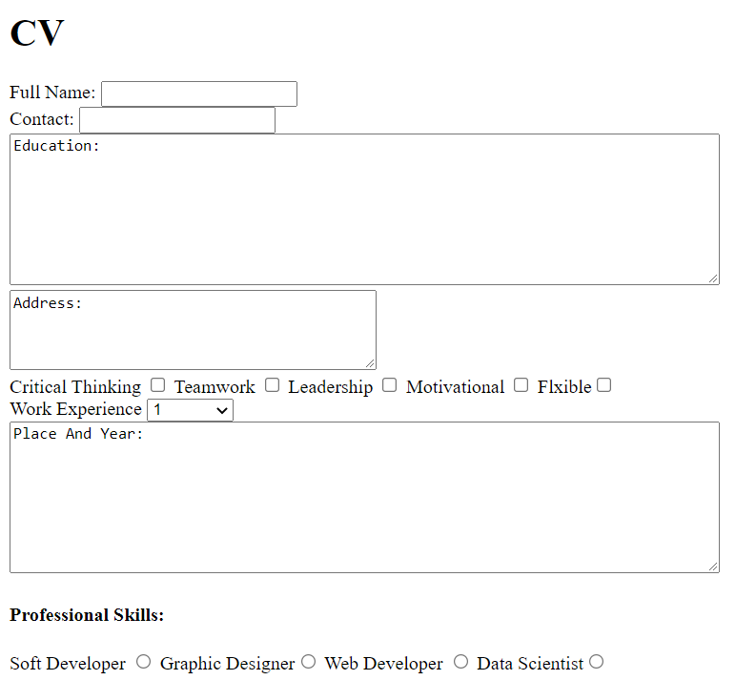

# LAB # 3

**1. Write down the advantages and disadvantages of HTML5.**

. **Advantages:**

HTML5 includes new elements for better structure, better form handling, drawing, and for media content like:

* The <canvas> element for 2D drawing
* The <video> and <audio> elements for media playback
* Support for local storage
* New content-specific elements, like <article>, <footer>, <header>, <nav>, <section>
* New form controls, like calendar, date, time, email, url, search

**Disadvantages:**

HTML5 is not yet an official standard, and no browsers have full HTML5 support. But all major browsers continue to add new HTML5 features to their latest versions.

# LAB # 4



**1.**



**Create the form shown in the figure below.**

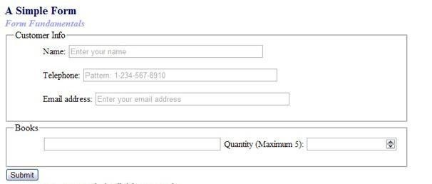

Code:

<!DOCTYPE html>

<html lang="en">

<head>

<meta charset="UTF-8">

<meta http-equiv="X-UA-Compatible" content="IE=edge">

<meta name="viewport" content="width=device-width, initial-scale=1.0">

<title>Document</title>

</head>

<body>

<form autocomplete="on">

<h2 style="color:#00C">A Simple Form</h2>

<h4 style="color:rgb(70, 62, 107)"><i>Form Fundamentals</i></h4>

<fieldset>

<legend>Customer Info</legend>

<label for="Name" >Name: </label>

<input type="text" placeholder="Enter your name" required autofocus><br><br>

<label for="Telephone" >Telephone: </label>

<input type="text" id="tele" placeholder="Pattern: 1-234-567-8910 " pattern="[0-9-]+" minlength="12" maxlength="12" required ><br><br>

<label for="Email" >Email: </label>

<input type="email" placeholder="Enter your email address" size=" 30" required ><br>

</fieldset> <br>

<fieldset>

<legend>Books</legend>

<label for="List">Books</label>

<input list="boooooks" name="Book list"/>

<datalist id="books">

<option >Sherlook homes part 1</option>

<option>Sherlook homes part 2</option>

<option>Sherlook homes part 3</option>

<option>Sherlook homes part 4</option>

</datalist>

<label for="Quantity" >Quantity(Maximum 5): </label>

<input type="number" min="1" max="5" required>

</fieldset><br>

<input type="submit">

</form>

</body>

</html>

**Output:**

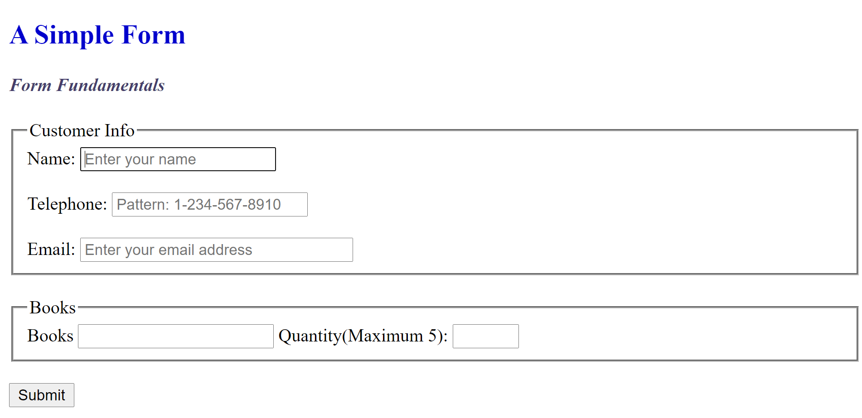

**DEPARTMENT OF SOFTWARE ENGINEERING**

**BACHELORS IN SOFTWARE ENGINEERING**

Practical Teacher: Engr. Muhammad Faraz Hyder____

Course Code**:** ___**SE-206**__ Course: **_____Web Engineering_____**

**Lab-4: ________Exploring HTML5 Elements. _____________**

**Student Roll No: ___SE-19028____ Student Name: ____Kabeer Ahmed___**

## Rubrics for Assessment of Practical for P3 Level (PLO-5 Modern Tool Usage)

|  |  |  |
| --- | --- | --- |
| **Rubric** | **Comments if any** | **Rating - 0 to 10** |
| How well student understood the given lab problem |  |  |
| How well the student expressed the  Solution |  |  |
| Proficiency in use of Tools |  |  |
| **Average Score** |  |  |

**Date:** **_5th August, 2021_______** **Practical Teacher Signature**: ___________________

# LAB # 5

**1. What are the advantages and disadvantages of CSS?**

## Advantages of CSS

**Consistently Efficient:**

CSS improves web master efficiency, especially when applying and changing style elements. With CSS, developers no longer need to change each page one at a time. CSS enables web designer efficiency; giving designers the power to alter an entire website or folder with only a few lines of code, ensuring consistency throughout for a global audience.

**Improves Site Speed:**

Less code simply means faster load time. When you use CSS, designers can reduce the amount of lines of programming for each page, which makes a website faster than the-other-site who does not use CSS. This is a huge advantage over website owners who keep users on pins and needles, waiting for the page to load.

**Low Maintenance:**

CSS simplifies website maintenance and gives web developers and designers one page to manage, making it easy for web masters to format, manage, and change one element on any whim from one spot — everything is now easier to control and alter when compared with HTML.

## Disadvantages of CSS

**Fragmentation:**

CSS renders different dimensions with each browser. Programmers are required to consider and test all code across multiple browsers for compatibility before taking any website or mobile application live.

**Different Levels*:***

There are different levels to CSS: CSS; CSS 2; CSS 3. This has been confusing for developers and browsers. One language is preferred.

**2. What is the advantage of CSS web design over tables.**

**Consistency:**

By making one change to your website's CSS style sheet, you can automatically make it to every page of your website. The bigger your website, the more time CSS saves you. And not only does CSS save time, it also ensures that your web pages have consistent styling throughout your site.

**Bandwidth Reduction:**

When CSS separates your website's content from its design language, you dramatically reduce your file transfer size. Your CSS document will be stored externally, and will be accessed only once when a visitor requests your website. In contrast, when you create a website using tables, every page of your website will be accessed with each visit. Your reduced bandwidth needs will result in a faster load time and could cut your web hosting costs.

**Search Engines:**

CSS is considered a clean coding technique, which means search engines won't have to struggle to "read" its content. Also, using CSS will leave your website with more content than code – and content is critical to your search engine success.

**Browser Compatibility:**

The recent arrival of Google® Chrome is further evidence that today's Internet users have more browser options than ever before, which makes browser compatibility a major issue for your website. CSS style sheets increase your website's adaptability and ensure that more visitors will be able to view your website in the way you intended.

**Viewing Options:**

Another common web design concern is the increasing need to make websites available for different media. CSS can help you tackle this challenge by allowing the same markup page to be presented in different viewing styles —— for example, you may create a separate style sheet for print or for a mobile device.

With so many advantages to offer, CSS is a wise choice for web design. If you're interested in making your website load faster, look better and rank higher, consider using CSS to create a new website or improve an existing website.

**DEPARTMENT OF SOFTWARE ENGINEERING**

**BACHELORS IN SOFTWARE ENGINEERING**

### Practical Teacher: Engr. Muhammad Faraz Hyder____

Course Code**:** ___**SE-206**__ Course: **_____Web Engineering_____**

**Lab-5: _____________________** **Introduction to Cascading Style Sheets. _____________________**

**Student Roll No: ___SE-19028____ Student Name: ____** **Kabeer Ahmed __**

### Rubrics for Assessment of Practical for P3 Level (PLO-5 Modern Tool Usage)

|  |  |  |
| --- | --- | --- |
| **Rubric** | **Comments if any** | **Rating - 0 to 10** |
| How well student understood the given lab problem |  |  |
| How well the student expressed the  Solution |  |  |
| Proficiency in use of Tools |  |  |
| **Average Score** |  |  |

**Date: ____6th August, 2021_______** **Practical Teacher Signature**: ___________________

# LAB # 6

1. **Define a function max () that takes two numbers as arguments and returns the largest of them. Use the** **if-else construct.**  Ans: **function max(n1,n2){ if(n1 > n2) return n1;**

**else**

**return n2;**

**}**

**console.log("The maximum of 4 and 3 is : " + max(4,3));**

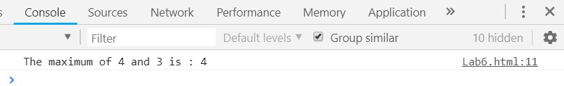

1. **Write a function that takes a single character and returns true of it is vowel and false otherwise.**

function charCheck(char){ char = char.toLowerCase();

if(char === 'a' || char === 'e' || char === 'i' || char === 'o' || char === 'u') return true else

return false;

}

console.log(charCheck('a')); console.log(charCheck('A')); console.log(charCheck('z'));

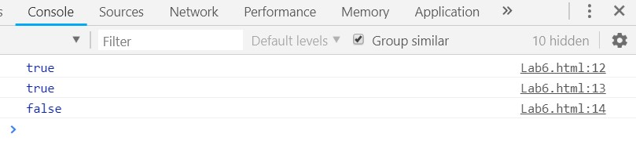

1. **Define a function sum() and multiply() that sums and multiplies all numbers in an array. E.g; sum([1,2,3,4]) should return 10 and multiply([1,2,3,4]) should return 24.** Ans: function sum(arr){

|  |  |
| --- | --- |
|  | return (arr.reduce(function (sum,val){ |
|  | return val + sum; |
| } | })); |
|  | function multiply(arr){ |
|  | return (arr.reduce(function (sum,val){ |
|  | return val * sum; |
| } | })); |

console.log("Sum of the elements of array [1,2,3,4] is:" + sum([1,2,3,4])); console.log("Product of the elements of array [1,2,3,4] is:" + multiply([1,2,3,4]));

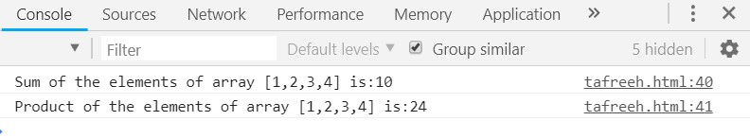

1. **Define a function reverse() that reverses the string supplied to it.**

Ans: function reverse(s){ return s.split("").reverse().join("");

}

var str = "Hello"; console.log(reverse(str));

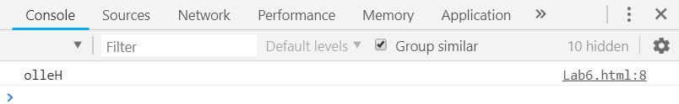

1. **Create a HTML form that has number of textboxes when the form runs in the browser fill the textboxes with data. Write a script that verifies that all the text boxes have been filled. If a textbox is left empty pop up an alert indicating which box has been left empty. When the OK button of alert is clicked, the focus must be transferred to that specific textbox otherwise display THANK YOU.** Ans:

<form action="">

<label>First Name: <input type="text" id="fname"></label><br>

<label>Last Name: <input type="text" id="lname"></label><br>

<label>Email: <input type="text" id="email"></label><br>

<label>Address: <input type="text" id="add"></label><br>

<label>Phone: <input type="text" id="phone"></label><br>

<input type = "button" onclick="checkForm()" value="submit">

</form>

<script type="text/javascript"> function focusField(fieldName)

{

document.getElementById(fieldName).focus();

}

function checkForm(){ var fname =

document.getElementById("fname").value; var lname = document.getElementById("lname").value; var email = document.getElementById("email").value; var address = document.getElementById("add").value; var phone = document.getElementById("phone").value;

if(!fname.trim()){ alert("First Name field is empty"); focusField("fname")

}

else if(!lname.trim()){ alert("Last Name field is empty"); focusField("lname")

}

else if(!email.trim()){ alert("Email

field is empty");

focusField("email")

}

else if(!address.trim()){ alert("Address field is empty"); focusField("add")

}

else if(!phone.trim()){ alert("Phone no field is empty"); focusField("phone");

}

else

alert("THANK YOU");

}

**Output:**

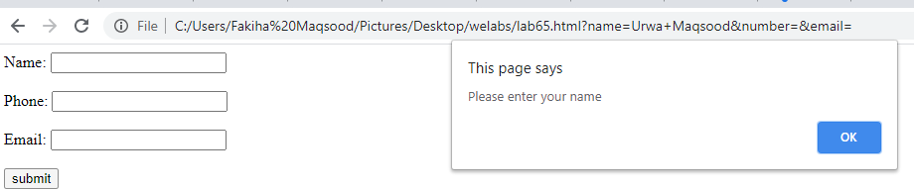

**DEPARTMENT OF SOFTWARE ENGINEERING**

**BACHELORS IN SOFTWARE ENGINEERING**

Practical Teacher: Engr. Muhammad Faraz Hyder____

Course Code**:** ___**SE-206**__ Course: **_____Web Engineering_____**

**Lab-6: _____________________ Introduction to JavaScript. _____________________**

**Student Roll No: ___SE-19028____ Student Name: ____Kabeer Ahmed__**

## Rubrics for Assessment of Practical for P3 Level (PLO-5 Modern Tool Usage)

|  |  |  |
| --- | --- | --- |
| **Rubric** | **Comments if any** | **Rating - 0 to 10** |
| How well student understood the given lab problem |  |  |
| How well the student expressed the  Solution |  |  |
| Proficiency in use of Tools |  |  |
| **Average Score** |  |  |

**Date: ____6th August, 2021_______** **Practical Teacher Signature**: ___________________

**LAB #7**

**1. Write down the advantages of server-side scripting in ASP.Net**

* Keeps your Asp.net applications secured with the built-in Windows authentication and per application configuration.
* Asp.Net has reduced the long lines of code required to develop large applications.
* Asp.Net and Html, together generate dynamic web pages smoothly.
* Being an ideal server-side scripting technology, Asp.Net code first runs on Windows server before displaying on the web browser.
* Asp.Net framework is language independent, means you can choose any programming language which best suited to your application.
* With the built-in configuration information, Asp.Net is easy to deploy.
* The windows web server thoroughly monitors the web pages, multiple components, and applications running over it.
* The Dot Net Framework quickly gives an alert for memory leaks, unbounded loops, and other wrong behaviors, immediately killing them and restart them over again.
* Asp.Net features like early binding, JIT compilation, caching services and native optimization supports gives your application the high level of performance.
* All the Asp.Net applications are highly monitored and managed to help application available to handle requests.
* The best part of Dot Net Framework is it has its own built-in caching features.
* The content and the program logic are separated in the .Net Framework, thus reducing the program inconveniences.

# LAB # 11

**Write any simple PHP script that performs some mathematical operations and attach the screenshot of the output.**

Ans: <?php

$x = 10; $y = 20;

echo "The sum of ".$x." and ".$y." is ".($x + $y)."<br />"; echo "The difference of ".$x." and ".$y." is ".($x - $y)."<br />"; echo "The product of ".$x." and ".$y." is ".($x * $y)."<br />"; echo "The division of ".$x." and ".$y." is ".($x/$y)."<br />"

?>

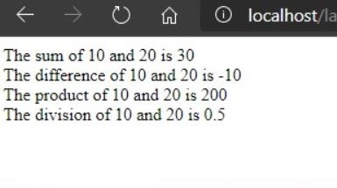

**DEPARTMENT OF SOFTWARE ENGINEERING**

**BACHELORS IN SOFTWARE ENGINEERING**

Practical Teacher: Engr. Muhammad Faraz Hyder____

Course Code**:** ___**SE-206**__ Course: **_____Web Engineering_____**

**Lab-11: ________________ Introduction to PHP ________________________**

**Student Roll No: ___SE-19028____ Student Name: ____Kabeer Ahmed__**

## Rubrics for Assessment of Practical for P3 Level (PLO-5 Modern Tool Usage)

|  |  |  |
| --- | --- | --- |
| **Rubric** | **Comments if any** | **Rating - 0 to 10** |
| How well student understood the given lab problem |  |  |
| How well the student expressed the  Solution |  |  |
| Proficiency in use of Tools |  |  |
| **Average Score** |  |  |

**Date: ____7th August, 2021_______** **Practical Teacher Signature**: ___________________

**LAB #12**

**Write PHP code to declare an associative array of six elements that has supermarket item names associated with their price. Use a function to calculate the total price of all items purchased. Print the array using for each loop followed by the total cost of items. The program should output the following text on the browser screen:**

**Ans:**

<!DOCTYPE html>

<html>

<body >

<!-- lab12 -->

<h2>LAB 12 </h2> <?php

$cart = ['cereal' => "5.00", 'coffee beans' => "2.50", 'bananas' => "3.50", 'onion' => "1.00", 'lettuce' => "2.40", 'tomato' => "1.00"];

$total = 0;

print_r($cart);

foreach($cart as $product => $price)

{ echo "<br>" . $product . " costs $" . $price;

$total += $price;

}

echo "<br> The total price of your items is $" . $total; ?>

</body>

</html>

**Output:**

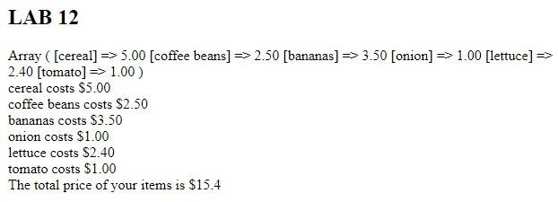

**DEPARTMENT OF SOFTWARE ENGINEERING**

**BACHELORS IN SOFTWARE ENGINEERING**

Practical Teacher: Engr. Muhammad Faraz Hyder____

Course Code**:** ___**SE-206**__ Course: **_____Web Engineering_____**

**Lab-12: ______________ PHP Variables, Control Structures and Loops ___________________________**

**Student Roll No: ___SE-19028____ Student Name: ____Kabeer Ahmed___**

## Rubrics for Assessment of Practical for P3 Level (PLO-5 Modern Tool Usage)

|  |  |  |
| --- | --- | --- |
| **Rubric** | **Comments if any** | **Rating - 0 to 10** |
| How well student understood the given lab problem |  |  |
| How well the student expressed the  Solution |  |  |
| Proficiency in use of Tools |  |  |
| **Average Score** |  |  |

**Date____7th August, 2020_______** **Practical Teacher Signature**: ___________________

# LAB # 13

**Write a simple PHP script to create database, tables and then insert some dummy data. And attach the screenshot of the output**

**Ans:**

<!DOCTYPE html>

<html lang="en">

<head>

<meta charset="UTF-8">

<meta name="viewport" content="width=device-width, initial-scale=1.0">

<title>Document</title>

</head>

<body>

<?php

$hostname = "localhost";

$username = "user";

$password = "pass";

$dbname = "information";

$conn = new mysqli($hostname, $username, $password, $dbname);

$sql = "CREATE DATABASE information";

$sql = "CREATE TABLE customers ( citycode SERIAL PRIMARY KEY, customername VARCHAR(50),

loc VARCHAR(50) )";

$sql = "INSERT INTO customers

VALUES(5446, 'MARK', 'SINGAPORE')";

$conn->close();

?>

</body>

</html>

**Output:**

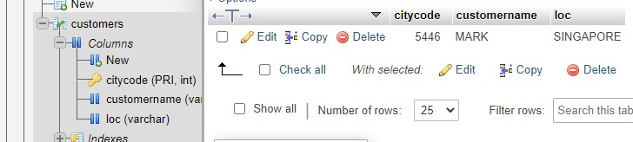

**DEPARTMENT OF SOFTWARE ENGINEERING**

**BACHELORS IN SOFTWARE** **ENGINEERING**

### Practical Teacher: Engr. Muhammad Faraz Hyder____

Course Code**:** ___**SE-206**__ Course: **_____Web Engineering_____**

**Lab-13: ______________________MySQL AND PHP_________________________**

**Student Roll No: ___SE-19028____ Student Name: ____Kabeer Ahmed___**

### Rubrics for Assessment of Practical for P3 Level (PLO-5 Modern Tool Usage)

|  |  |  |
| --- | --- | --- |
| **Rubric** | **Comments if any** | **Rating - 0 to 10** |
| How well student understood the given lab problem |  |  |
| How well the student expressed the  Solution |  |  |
| Proficiency in use of Tools |  |  |
| **Average Score** |  |  |

**Date:** **____8th August, 2020_______** **Practical Teacher Signature**: ___________________

# LAB # 14

**1. Write a simple PHP script to connect to the database and perform some simple operations like SELECT, INSERT, UPDATE, DELETE etc. and attach the screenshot of the output**

**Ans:**

<!DOCTYPE html>

<html lang="en">

<head>

<meta charset="UTF-8">

<meta name="viewport" content="width=device-width, initial-scale=1.0">

<title>Document</title>

</head>

<body>

<?php

$hostname = "localhost";

$username = "user";

$password = "pass";

$dbname = "information";

$conn = new mysqli($hostname, $username, $password, $dbname);

$sql = "CREATE DATABASE information";

$sql = "CREATE TABLE customers ( citycode SERIAL PRIMARY KEY, customername VARCHAR(50),

loc VARCHAR(50) )";

$sql = "INSERT INTO customers

VALUES(5446, 'MARK', 'SINGAPORE')";

$conn->close();

?>

</body>

</html>

## OUTPUT



**DEPARTMENT OF SOFTWARE ENGINEERING**

**BACHELORS IN SOFTWARE ENGINEERING**

Practical Teacher: Engr. Muhammad Faraz Hyder____

Course Code**:** ___**SE-206**__ Course: **_____Web Engineering_____**

**Lab-;14: ____________Select, Insert, Update and Delete in PHP/MYSQL _______________________**

**Student Roll No: ___SE-19028____ Student Name: ____Kabeer Ahmed___**

### Rubrics for Assessment of Practical for P3 Level (PLO-5 Modern Tool Usage)

|  |  |  |
| --- | --- | --- |
| **Rubric** | **Comments if any** | **Rating - 0 to 10** |
| How well student understood the given lab problem |  |  |
| How well the student expressed the  Solution |  |  |
| Proficiency in use of Tools |  |  |
| **Average Score** |  |  |

**Date: ____8th August, 2020_______** **Practical Teacher Signature**: ___________________